ACCUVMC CNC MILLING MACHINE
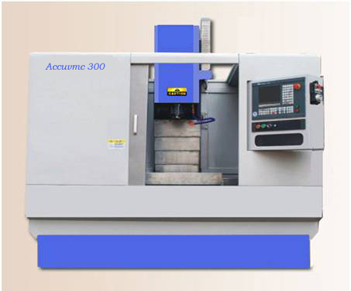

TRAVEL | ACUVMC-300
X Axis | 300 mm
Y Axis | 250 mm
Z Axis | 300 mm
Distance between Table top and spindle nose | 50-350
Table Size | 450x260 mm
Maximum Load on Table | 100 Kg
SPINDLE
Spindle Motor Capacity | 2HP
Spindle Speed (RPM) | 3000
Spindle Nose Taper | BT-30
Accuracy
Positioning accuracy | 0.010
Repeatability | 0.010
FEED RATE
Rapid Travers X.Y.Z | 5 m
X. Y. Z | 0-5000
POWER
Transformer for Drives | 220V, 3 Phase
Main Supply | 415V+ 2% 50 Hz
CNC
Control System | Siemens & Hust
Servo Motors | 4 Nm X, Y,Z
SLIDES
Slides | Linear motion guide ways  Taiwan Make
Ball Screws X, Y and Z axis | Taiwan Make
Lubrication | Automatic
Chip Tray & Coolant Tank | 75 Ltr
MACHINE DIMENSIONS
Height x Length x width | 2000 x 1650 x 1500
Machine Weight (approx) | 1500 Kg
Marketed by :-
INDIA INTERNATIONAL MARKETING COMPANY
DELHI

